
Bank Customer Churn Prediction

This dataset, which can be found in https://www.kaggle.com/datasets/shubhammeshram579/bank-customer-churn-prediction, contains information about customer churn in the banking industry. It contains 12 features and 10002 samples, aiming to predict whether a customer will leave the bank or not. The target column is called “Exited” where a value of 1 indicates that the customer has left the bank and a value of 0 indicates they haven’t.
Isalos version used: 2.0.6

Step 1: Import data from file
Right click on the input spreadsheet (left) and choose the option “Import from File”. Then navigate through your files to load the one with the bank customer churn data.
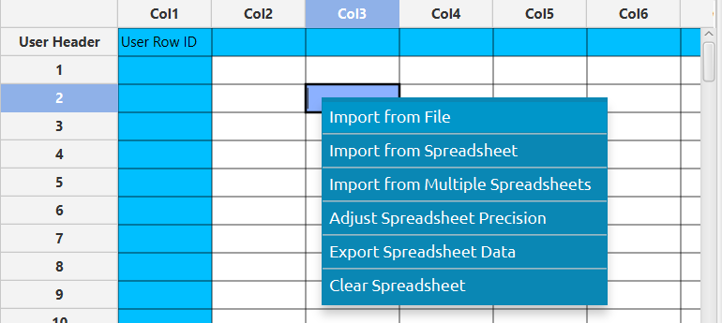

The data will appear on the left spreadsheet.
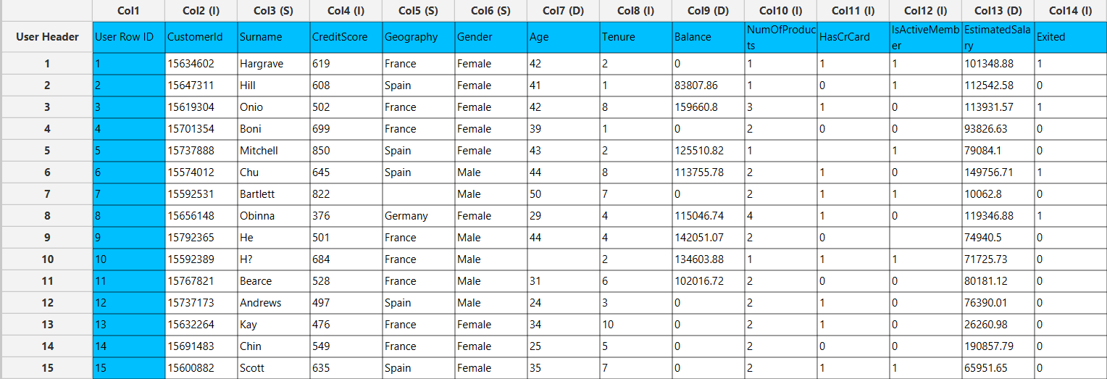

Step 2: Manipulate data
From the available columns we will select the ones that will be useful features for predicting customer churn. Customer IDs and surnames do not provide any useful information about customer behaviour, so they will be left out. On the menu click on Data Transformation $→$ Data Manipulation $→$ Select Column(s) and select the rest of the columns.

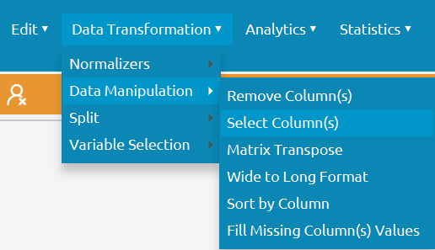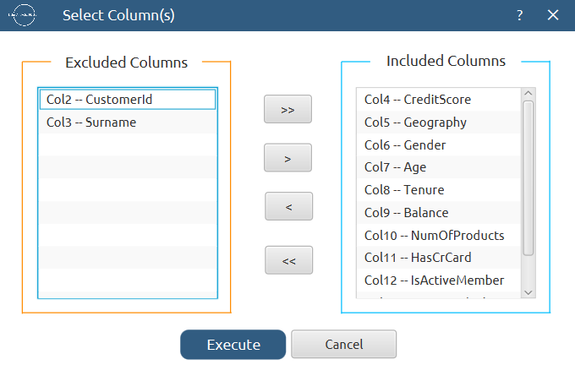

The selected data will appear in the output (right) spreadsheet. This tab can be renamed “IMPORT” by right-clicking on it and choosing the “Rename” option.
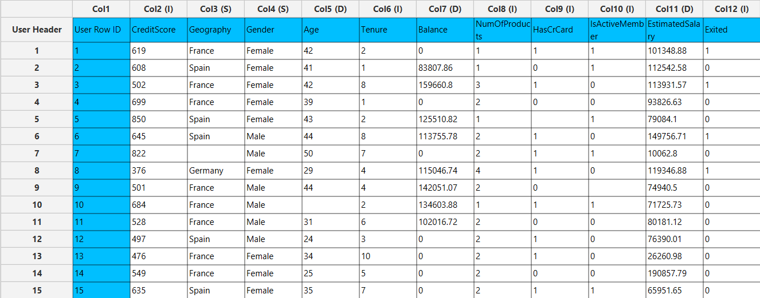

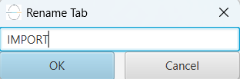

Step 3: Fill missing data
This dataset includes some missing values therefore we need to fill them appropriately. Create a new tab by pressing the “+” button on the bottom of the page with the name “FILL_MISSING” which we will use for filling the missing values.
Import data into the input spreadsheet of the “FILL_MISSING” tab from the output of the “IMPORT” tab by right-clicking on the input spreadsheet and then choosing “Import from Spreadsheet”.



To fill the missing data, choose: Data Transformation $→$ Data Manipulation $→$ Fill Missing Column(s) Values
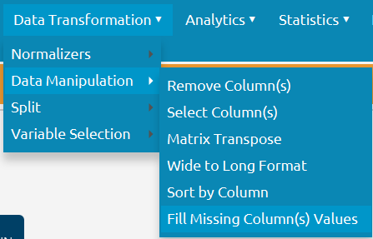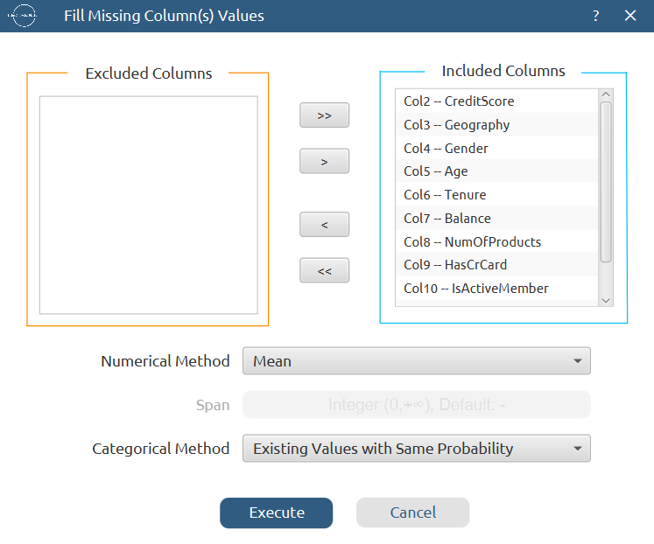

The results will appear on the output spreadsheet.

Step 4: Split data
Create a new tab by pressing the “+” button on the bottom of the page with the name “TRAIN_TEST_SPLIT” which we will use for splitting the train and test set.
Import data into the input spreadsheet of the “TRAIN_TEST_SPLIT” tab from the output of the “FILL_MISSING” tab by right-clicking on the input spreadsheet and then choosing “Import from Spreadsheet”.
Split the dataset by choosing Data Transformation $→$ Split $→$ Random Partitioning. Then choose the “Training set percentage” and the column for the sampling as shown below:

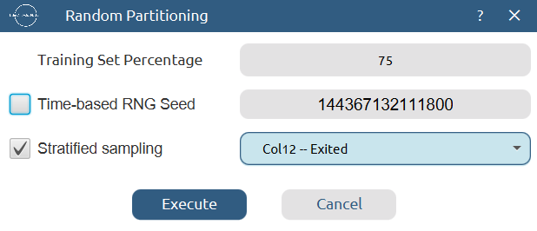

The results will be two separate spreadsheets, “TRAIN_TEST_SPLIT: Training Set” and “TRAIN_TEST_SPLIT: Test Set”, which will be available to import into the next tabs.

Step 5: Normalize the training set
Create a new tab by pressing the “+” button on the bottom of the page with the name “NORMALIZE_TRAIN_SET”.
Import into the input spreadsheet of the “NORMALIZE_TRAIN_SET” tab the train set from the output of the “TRAIN_TEST_SPLIT” tab by right-clicking on the input spreadsheet and then choosing “Import from Spreadsheet”. From the available Select input tab options choose “TRAIN_TEST_SPLIT: Training Set”.
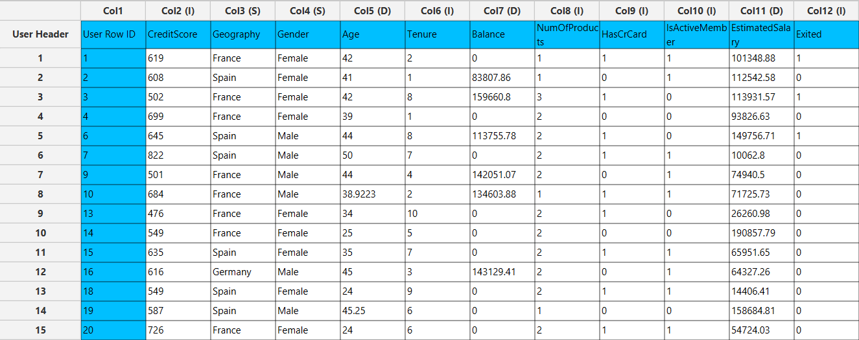

Normalize the data using Z-score: Data Transformation $→$ Normalizers $→$ Z Score and select all columns except the “Exited” target column.
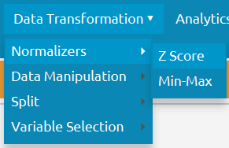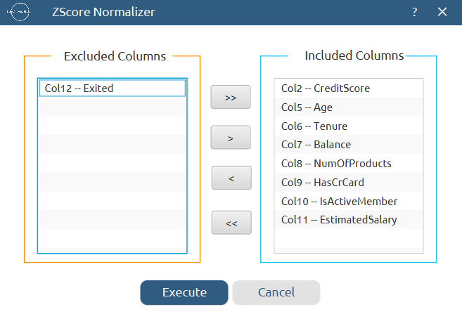

The results will appear on the output spreadsheet.
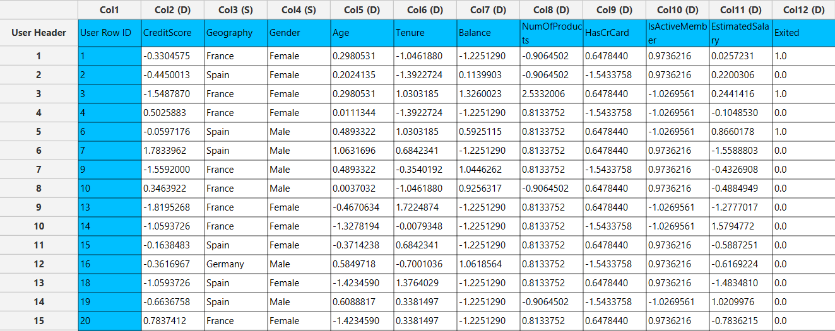

Step 6: Normalize the test set
Create a new tab by pressing the “+” button on the bottom of the page with the name “NORMALIZE_TEST_SET”.
Import into the input spreadsheet of the “NORMALIZE_TEST_SET” tab the test set from the output of the “TRAIN_TEST_SPLIT” tab by right-clicking on the input spreadsheet and then choosing “Import from Spreadsheet”. From the available Select input tab options choose “TRAIN_TEST_SPLIT: Test Set”.
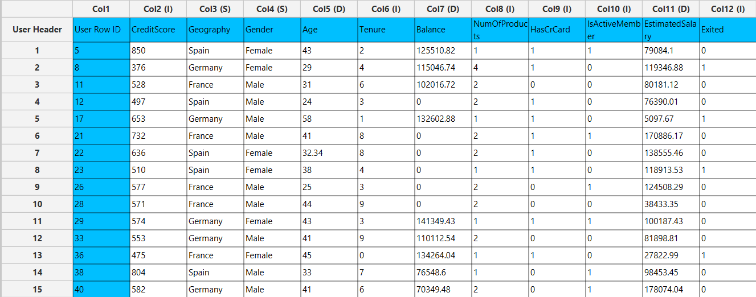

Normalize the test set using the existing normalizer of the training set: Analytics $→$ Existing Model Utilization $→$ Model (from Tab:) NORMALIZE_TRAIN_SET
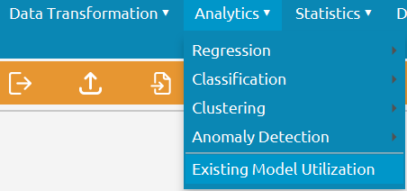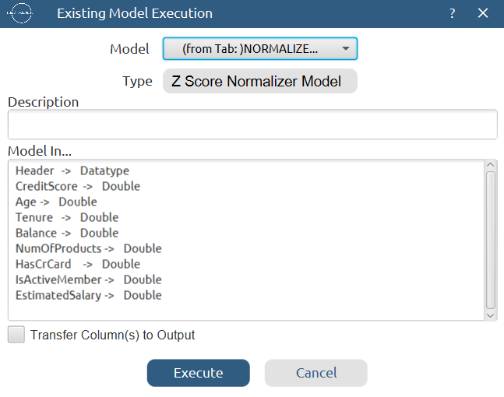

The results will appear on the output spreadsheet.
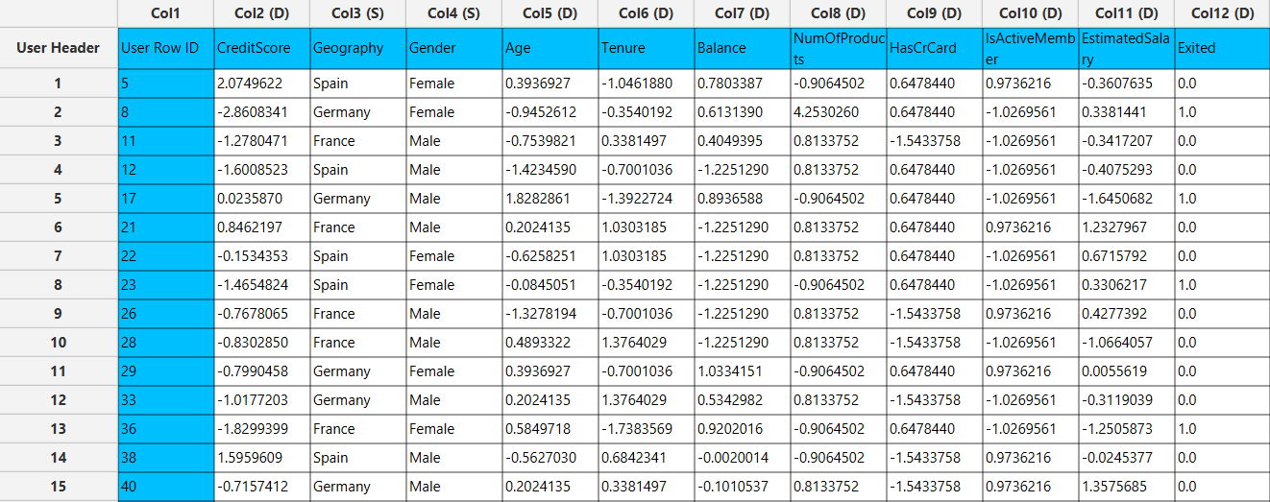

Step 7: Train the model
Create a new tab by pressing the “+” button on the bottom of the page with the name “TRAIN_MODEL(.fit)”.
Import data into the input spreadsheet of the “TRAIN_MODEL(.fit)” tab from the output of the “NORMALIZE_TRAIN_SET” tab by right-clicking on the input spreadsheet and then choosing “Import from Spreadsheet”.
Use the J48 Decision Tree Method to train and fit the model: Analytics $→$ Classification $→$ J48 Decision Tree
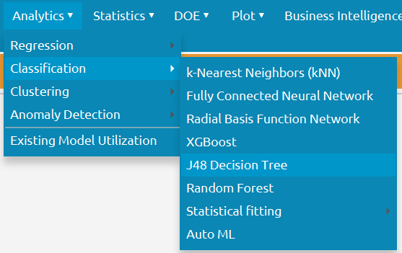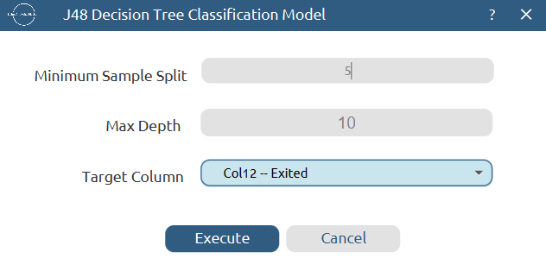

The predictions will appear on the output spreadsheet.
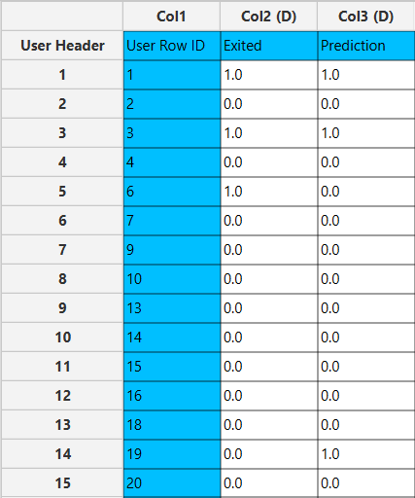

Step 8: Validate the model
Create a new tab by pressing the “+” button on the bottom of the page with the name “VALIDATE_MODEL(.predict)”.
Import data into the input spreadsheet of the “VALIDATE_MODEL(.predict)” tab from the output of the “NORMALIZE_TEST_SET” tab by right-clicking on the input spreadsheet and then choosing “Import from Spreadsheet”.
To validate the model: Analytics $→$ Existing Model Utilization$→$ Model (from Tab:) TRAIN_MODEL(.fit). Choose the column “Exited” to be transferred to the output spreadsheet.
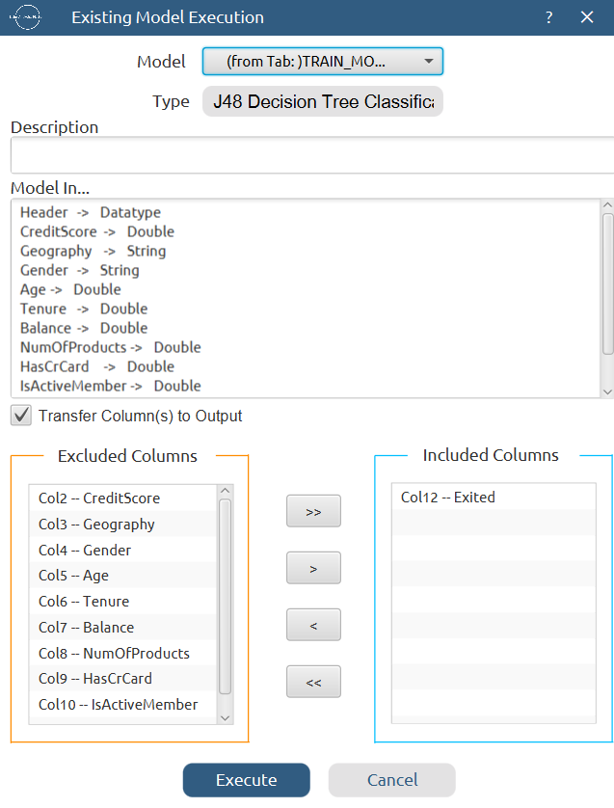

The predictions will appear on the output spreadsheet.
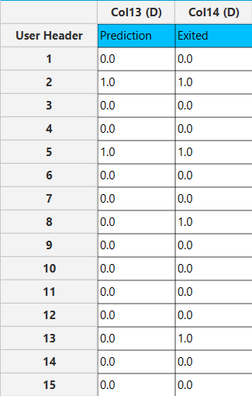

Step 9: Statistics calculation
Create a new tab by pressing the “+” button on the bottom of the page with the name “STATISTICS_ACCURACIES”.
Import data into the input spreadsheet of the “STATISTICS_ACCURACIES” tab from the output of the “VALIDATE_MODEL(.predict)” tab by right-clicking on the input spreadsheet and then choosing “Import from Spreadsheet”.
Calculate the statistical metrics for the classification: Statistics $→$ Model Metrics $→$ Classification Metrics
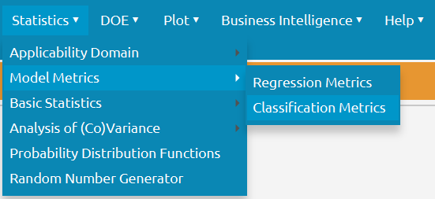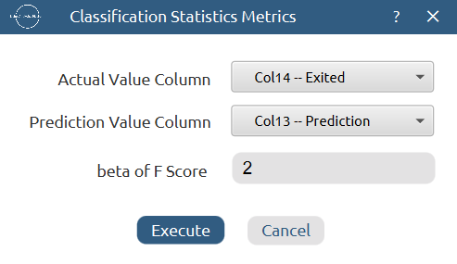

The results will appear on the output spreadsheet.

Step 10: Reliability check for each record of the test set

Step 10.a: Create the domain
Create a new tab by pressing the “+” button on the bottom of the page with the name “EXCLUDE_EXIT”.
Import data into the input spreadsheet of the “EXCLUDE_EXIT” tab from the output of the “NORMALIZE_TRAIN_SET” tab by right-clicking on the input spreadsheet and then choosing “Import from Spreadsheet”.
Manipulate the data to exclude the target column “Exited”: Data Transformation $→$ Data Manipulation $→$ Select Column(s)
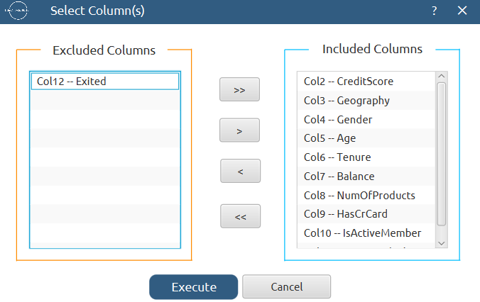

The results will appear on the output spreadsheet.
Create a new tab by pressing the “+” button on the bottom of the page with the name “DOMAIN”.
Import data into the input spreadsheet of the “DOMAIN” tab from the output of the “EXCLUDE_EXIT” tab by right-clicking on the input spreadsheet and then choosing “Import from Spreadsheet”.
Create the domain: Statistics $→$ Applicability Domain $→$ APD

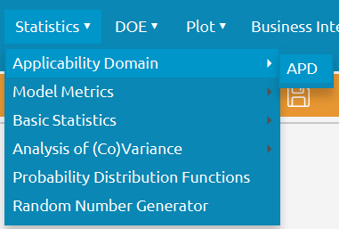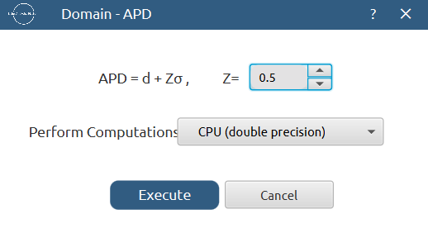

The results will appear on the output spreadsheet.
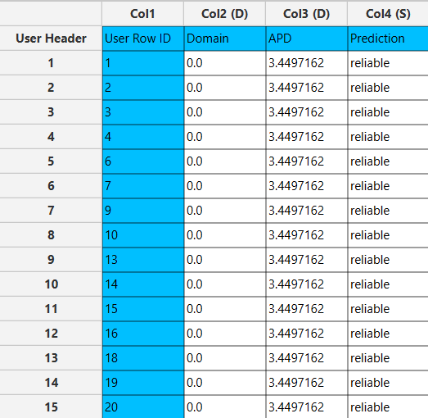

Step 10.b: Check the test set reliability
Create a new tab by pressing the “+” button on the bottom of the page with the name “EXCLUDE_EXIT_TEST_SET”.
Import data into the input spreadsheet of the “EXCLUDE_EXIT_TEST_SET” tab from the output of the “NORMALIZE_TEST_SET” tab by right-clicking on the input spreadsheet and then choosing “Import from Spreadsheet”.
Manipulate the data to exclude the target column “Exited”: Data Transformation $→$ Data Manipulation $→$ Select Column(s)
The results will appear on the output spreadsheet.
Create a new tab by pressing the “+” button on the bottom of the page with the name “RELIABILITY”.
Import data into the input spreadsheet of the “RELIABILITY” tab from the output of the “EXCLUDE_EXIT_TEST_SET” tab by right-clicking on the input spreadsheet and then choosing “Import from Spreadsheet”.
Check the Reliability: Analytics $→$ Existing Model Utilization$→$ Model (from Tab:) DOMAIN
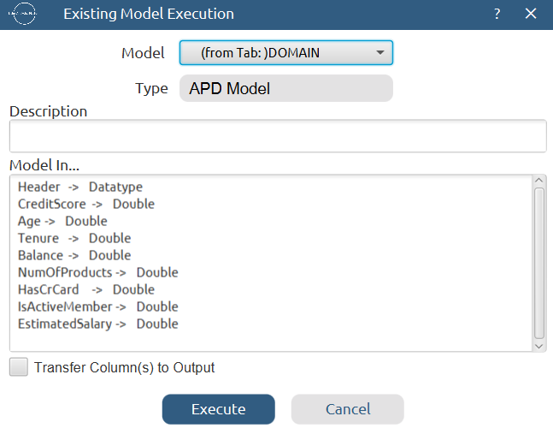

The results will appear on the output spreadsheet.
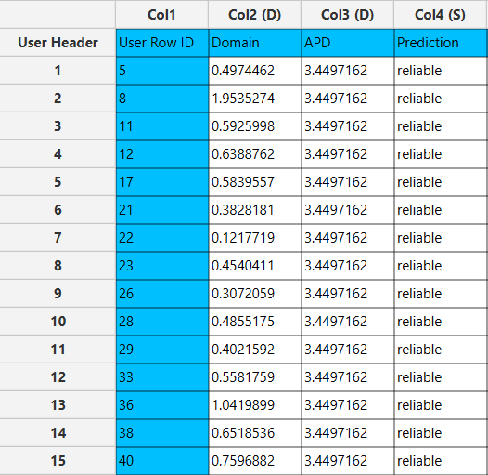

Final Isalos Workflow
Following the above-described steps, the final workflow on Isalos will look like this:
